**Email:** **danetremedical.practice@nhs.net**

**Website:** [**www.danetremedicalpractice.co.uk**](http://www.danetremedicalpractice.co.uk)

**Telephone:** **01327 703333**

PATIENT

NEWSLETTER

**Welcome to the Summer Edition of YOUR Patients’ Newsletter. We hope you enjoy reading through and finding out what’s happening within YOUR practice.**

***Issue: Summer 2024***

|  |
| --- |
| **Hay Fever Medication** |



With summer now nearly upon us, it is worth noting that medications for Hay Fever are no longer being routinely prescribed.

Prescribing readily available medication like antihistamines, nasal sprays and certain eye drops for hay fever costs the NHS millions every year, adding unnecessary strain on local GPs and the NHS.

Processing these prescriptions can cost 20 times the price of buying identical medication at your local pharmacy or supermarket. So, before you contact the surgery, please talk to your pharmacist.

|  |
| --- |
| **GP Registrations** |

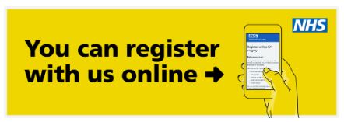Towards the end of the year all NHS GP registrations will be going online! This means to register with a new GP practice you will have to complete an online questionnaire and submit a copy of your ID documents via email for confirmation by your practice. We hope to have more information within the next few months.

|  |
| --- |
| **Keeping in Touch!** |

Don’t forget to keep us updated with your contact details! You can update us via Patient Online system; give us a call on 01327 703333 after 9am or contact us via email at [danetre.medicalpractice@nhs.net](mailto:danetre.medicalpractice@nhs.net)

|  |
| --- |
| **NHS App** |

If you are a patient at our practice, you can use the NHS App to access a range of NHS services on your smartphone or tablet.

It doesn’t replace existing services and you can still contact us in the usual ways. 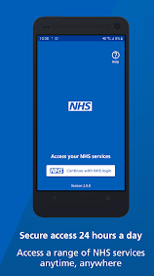However, once you have verified your identity in the app, you will have easy, 24/7 access to a growing range of health services and information such as:

* order repeat prescriptions
* access NHS 111 online
* find NHS services
* view your health records
* book appointments (such as Blood Tests, NHS Health Checks and Cervical Screening)
* & much more…

|  |
| --- |
| **Cervical Screening Campaign** |

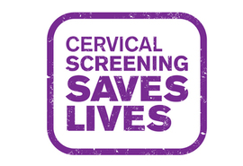

Since it’s establishment in 1988, cervical screening has saved an estimated 5000 lives a year. However, the numbers attending has fallen to a new 20 year low. It has been estimated that is everyone attended screening regularly, 83% of cervical cancer cases could be prevented. The ‘Cervical Screening Saves Lives’ campaign from Public Health England, aims to drive awareness of the risks and highlight the preventative benefits of screening. If due, please contact our Patient Services Team to book your screening test.

|  |
| --- |
| **NHS Health Checks** |

***Are you aged between 40-74?*** Did you know you could be eligible for a free NHS health check? This valuable assessment helps us to identify your risk from various conditions such as heart disease, diabetes, ***[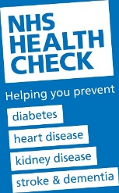](https://www.derbyshire.gov.uk/social-health/health-and-wellbeing/your-health/nhs-health-checks/nhs-health-checks.aspx)***kidney disease and even dementia. It can also help us to assess your risk for having a stroke. Knowing your risks is so important as it means that we can take steps **now** to stop these things before they develop into life changing or potentially life threatening conditions. *Please speak to our patient services team to confirm your eligibility.*

|  |
| --- |
| **Hello’s and Goodbye’s** |

We would like to offer a very warm welcome to the latest members of the Danetre Medical Practice Team:

Karen – Our new Patient Services Manager

Lauren, Nikita and Eleanor – Our additional Telephone Patient Services Advisors

We would also like to bid a farewell to Vicki and Vanessa who are moving on to pastures new. We wish you both all the best for the future.

|  |
| --- |
| **Going Abroad?** |

During the summer months you might be thinking about travelling abroad for a holiday. Please make sure that you plan ahead and get everything sorted so that you can have a happy and healthy trip.

Depending on your location, you may need additional vaccinations before entering another country. We are able to offer travel vaccines at the practice however these need to be planned at least **6-8 weeks ahead of travel**.

Vaccines available on the NHS are:

* Diphtheria, Tetanus & Polio
* Hepatitis A
* Typhoid
* Cholera (in some high risk travellers only)

For these you must complete the travel form which can be found on our website and either dropped in or emailed to the surgery. One of our Practice Nurses will then be in contact within 2 weeks to discuss your requirements and arrange appointments as needed. You may also find that there are private vaccinations which are also recommended for your destination, however these are not currently offered at the practice and would need to be arranged via a private travel clinic or larger pharmacy.

|  |
| --- |
| **COVID-19 Boosters** |

If you have been contacted directly by the NHS or are:

- aged 75 years old or over

- live in a care home for older adults

- are aged 6 months old or over and have a weakened immune system

You may be eligible for a COVID-19 booster vaccination. To book your vaccination please visit <https://www.nhs.uk/nhs-services/covid-19-services/> or call 119.

|  |
| --- |
| **Pushback to Secondary Care** |

As a county we are uniting and in the hope to make a stand towards secondary care and their expectations of GP practices. For some years, practices throughout Northamptonshire have been asked to organise work that should, by right, be completed either by the Hospitals or the Community Trusts (NHFT), even though no additional resources were offered to help us do this. Unfortunately, mounting primary care challenges mean this activity can no longer be sustained.

After much consideration, practices right across the county have advised the leadership that they can no longer undertake this unfunded activity. From 1st May 2024, we are asking the Hospitals and NHFT to complete all their own work. We will return correspondence to them where necessary.

|  |
| --- |
| **Training Dates** |

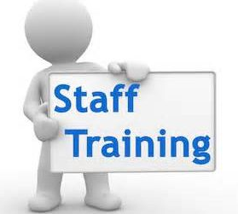**Please note our PLT Training dates below. (We will close at 12.30pm and re-open the following morning at 8am) Please call NHS111, think pharmacy first or ring 999 in an emergency if you require medical assistance.**

**10th July 2024**

**21st August 2024**

**11th September 2024**

**9th October 2024**

**13th November 2024**

**5th December 2024**